# Flynn’s arcade portfolio

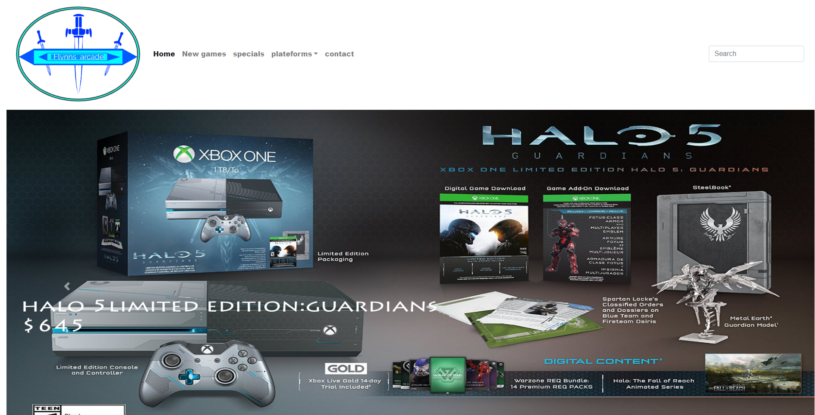

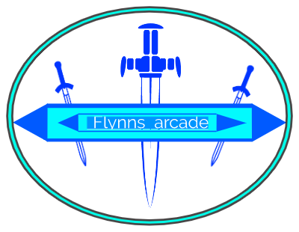

Design Brief

Flynn's Arcade has been slowly losing money as the trend for accessing video games has moved away from social 'video game arcades' to at home 'video game consoles' such as the Atari & Commadore 64. Flynn wants to reposition his business as a venue for selling new games and trading used games. Flynn wants you to design and create ‘alpha phase’ website that communicates his new business model. (More information on Flynn’s Arcade)

Areas of Investigation

*Comparison of website creation tools*

Comparison of Website creation tools (IDE, CMS, Drag and Drop)

IDE (integrated development environment) is a software application that provides comprehensive facilities to computer programmers for software development. An IDE normally consists of at least a source code editor, build automation tools and a debugger



Visual studio code is a code editor which helps you build and debug modern web and cloud applications

Other examples:



Komodo Edit



 NetBeans

Brackets

CMS allows people with limited code knowledge to edit and modify their website and helps create a template the data stored into CMS software is stored in a database which renders the webpage to create or edit a template.

Few example websites:



WordPress Joomla



Drupa



Dotclear

Drag and drop is basically an easy and much faster way to build a website. Drag and drop tool doesn't require any CSS skills or any code and allows anyone with a computer or laptop create a website under five minutes all you need to do is select a theme and choose any image you want and drag and drop it on the page it's great for businesses as they don't need to worry about their website Comparison of Website creation tools (IDE, CMS, Drag and Drop)

**Few example**

  
  
  
 Wix

Weebly

                                                    

                                                                    Webnode

Jimbo

Background research on Flynn and his design aesthetic

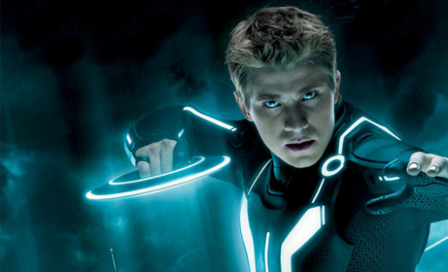Sam Flynn

Sam Flynn is the main character in Tron his mother died in a car accident and his father disappeared he was only six when his father disappeared he legally owns his father’s business (ENCOM) He inherited it after his father was vanished he became an orphan and went into the care of his grandparents years went on and he became a daredevil he performs extreme stunts including motorcycles and parachutes. On the anniversary of his father’s disappearance he causes trouble for the employees at ENCOM to remind them of the pressure of his father’s footsteps and to make them investigate deeper into hi fathers disappearance

Kevin Flynn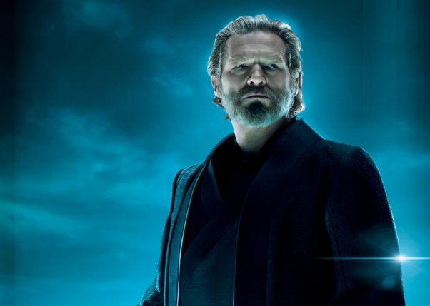

 Kevin Flynn was a talented programmer which created some of the bestselling games for ENCOM in the year 1982 including Space Paranoids, Matrix Blaster, Vice Squad and Light Cycle as he wrote the code for his upcoming video game another developer at ENCOM stole his code that developers name was Ed Dillinger who fired him after becoming Executive VP. Meanwhile he got married to Jordan Canas and had a son named Sam once his wife died in a car accident he focused all his time into creating a new digital game he was on the verge of new discoveries when he mysteriously disappeared.

Quorra

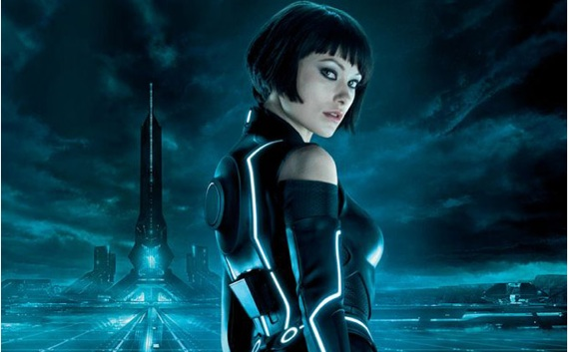Quoarra wants to experience the real world and wants her own life outside of the Tron world she is a friend of Kevin Flynn which shared the knowledge of the world outside of Tron.

Research on data communications and its implications for web design

Data communications is very important for web design and basic technology we use data communications to exchange messages it enables the movement of electrical or digital data from one place to another it provides the movement of electrical or digital data between two or more devices regardless of the distance of the two for an example it’s like connecting to the internet the router sends signals to the device and connects data communications mostly help send messages to one person to another without data communications comments, calls and basic messaging won’t be accessible as the message can’t travel without a network caring the message to another device.

This is very important for web design as it would take much longer to load it up and comments and messages won’t be available and this is mostly the point of websites and video games won’t be available to play or access and if somehow it does it would be very slow.

Design Sketches

Throughout my all my sketches I think this is the best one and have gone through trial and error to get to this point in my sketch I mostly struggled with the details and where to put all the advertisements and games I couldn’t decide if I wanted to put a big or small image for my front page at the end I decided on large and don’t regret it. I also added advertisements on the sides like a regular website at the top right corner I added store, account, gift card icons. And at the top left there is a search button.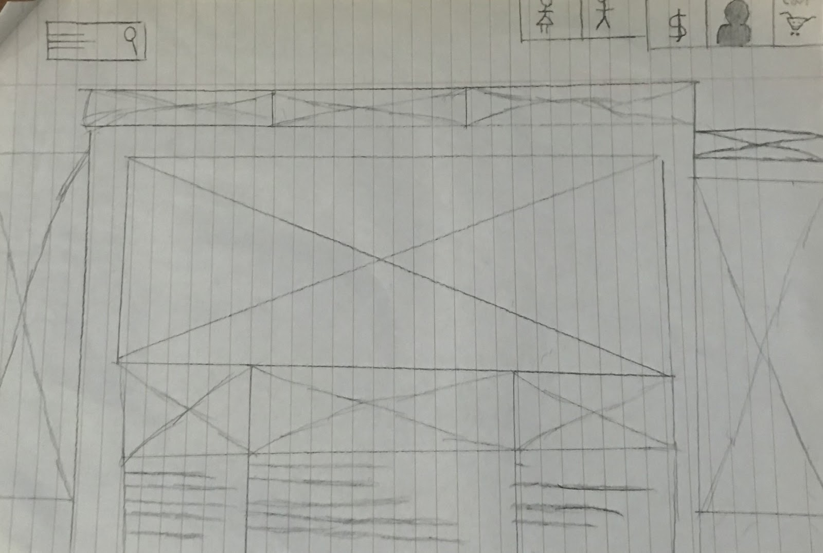

Reviews: some reviews I got on this was that I should use and add more texture and detail to the sides and top and a few more advertisements.

Final concept design

Detailed sitemap and wireframe of final design including proposed colour palate.

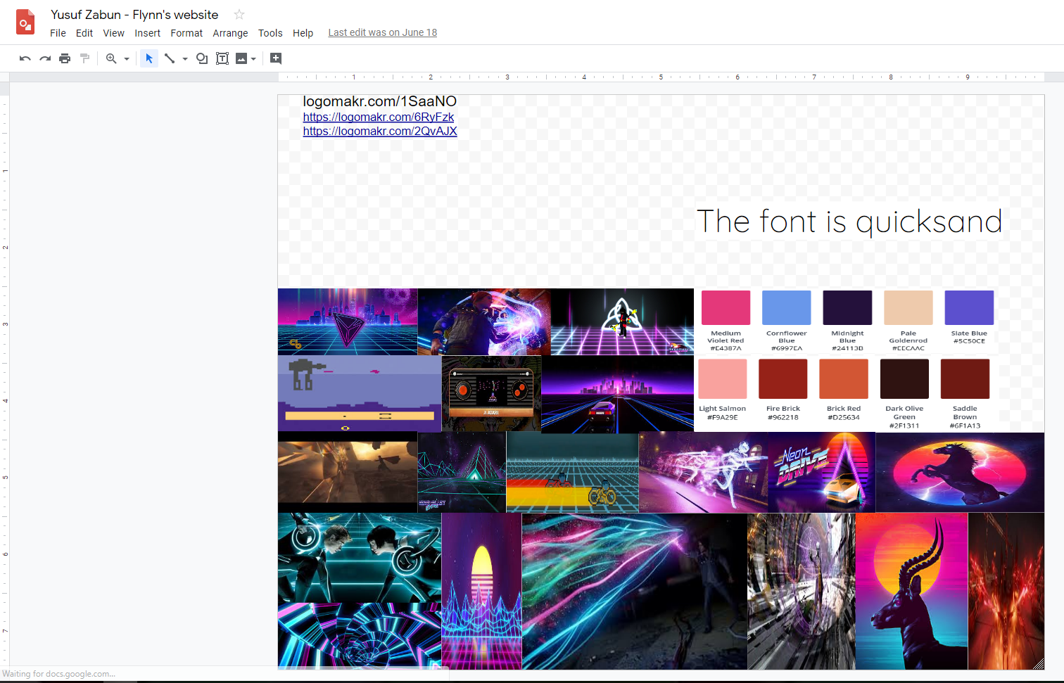

Design changes

I have done many design changes on my website I probably changed the icon colours and background colour on my website the most as each would not be what I wanted I settled on a dark blue background with grey icons. for the steam icon I originally put an icon for a computer or laptop but couldn’t find one and when I did people told me to change it so I put it to the steam icon as it’s more relevant and has more to do with video games then most consoles furthermore I changed the slider images to new games that came out this year or last year as the ones I did before were absolute garbage the images I used was Halo 5 guardians, Red Dead Redemption, Marvels Spider-Man and Black Ops 3 beforehand I had infamous second son and low quality images of Far cry looking back on it I’m extremely happy I changed them to higher quality images i saved and deleted so many images from my gallery my recently deleted garbage is most likely full at this point.

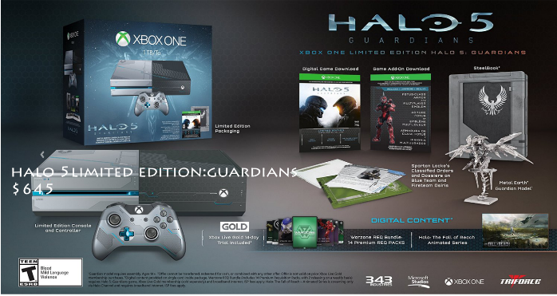

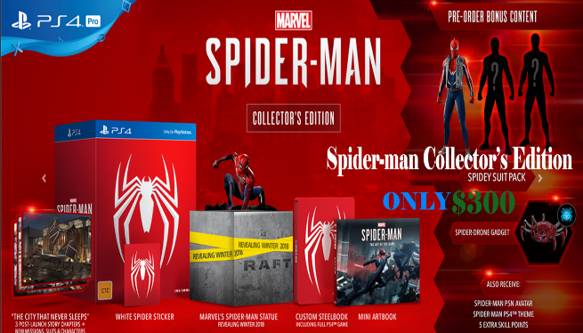

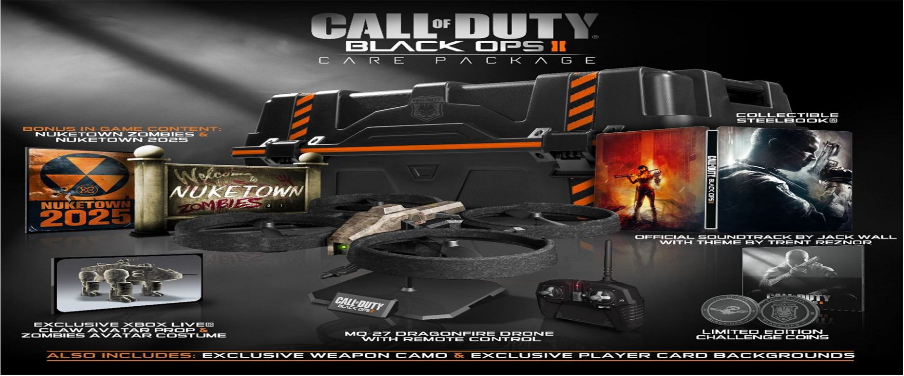

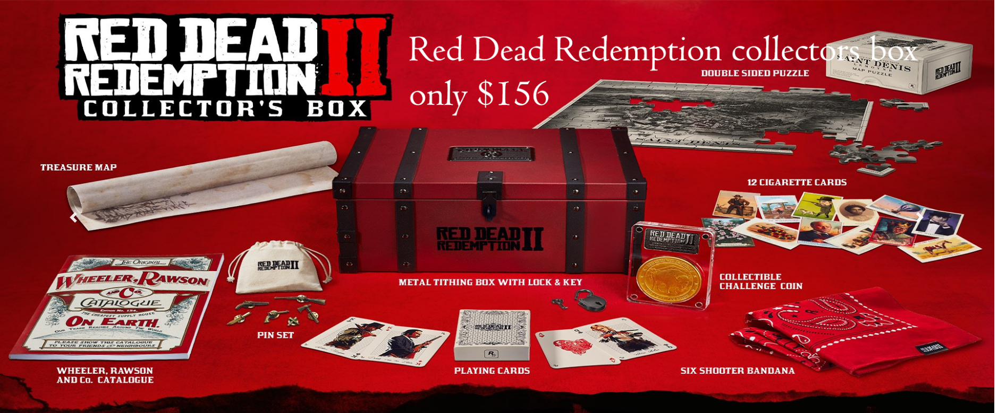

Evaluation

I finished the contact page where I put my phone number and email just to make it more realistic the map was added to the contact page I also put in the hours of the arcade. I had a few issues with the phone number and email but somehow managed to make it appear on the bottom left corner when hovered on. I wish I could’ve finished the rest of my website such as the specials, new game, membership bonus, social media which I couldn’t finish from a lack of time and resources however I’m mostly happy about my websites other assets such as the drop down menu and background colour unfortunately I couldn’t complete my website to its full potential but think it’s an ok website with minor setbacks.

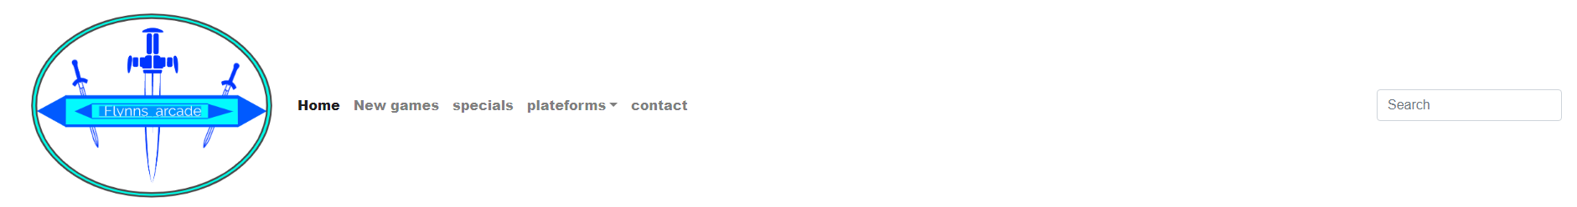

Bibliography

The first application we used was notepad++ which we used to build the body of our website after that we used Adobe Photoshop which we used to edit the images and add text to them the snipping tool help us cut out any unwanted parts of an image and save them to our gallery. Bootstrap made easy helped us create many things such as changes the color of our icons and for starters adding icons to our website it also teaches us how to use all the tools correctly and efficiently. GitHub helped us save and file the documents onto our accounts Style CSS helped us structure our website Flynn’s arcade website gave us a lot of important information to complete our website